NDIS Service Agreement
Easy English

NDIS Service Agreement
 | This service agreement is between
 | You:
 | You live at:
Us
Us means Country & Outback Health –
your NDIS provider
This agreement starts on:

This agreement ends on:
How to use this service agreement
 | Country & Outback Health wrote this service agreement. When you see the words “we’ or ‘us’, it means Country & Outback Health
 | We have written this services agreement in an easy to read way. We use pictures to explain some ideas. Some words are in bold. We will tell you what the word means.
 | You can ask for help to read this service agreement. A friend, family member or support person may be able to help you.
What is a service agreement?
This service agreement is about the services and supports you will get from us.
It explains the support that we will give you.
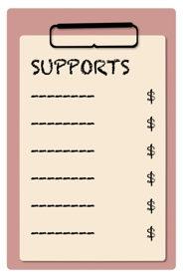 | At the end of this document, this is a list of:  • your supports  • their prices
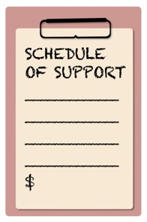 | We call this your Schedule of Supports.
This agreement also says:

• you need to do

• we need to do

• both of us need to do together
What you need to do
You need to:

Tell us how you want to get your supports
 | Tell us 2 days before if you want to cancel an appointment
 | Tell us if your NDIS plan changes or ends.
You can tell us what you think.
It is important that we know how you feel about our service.
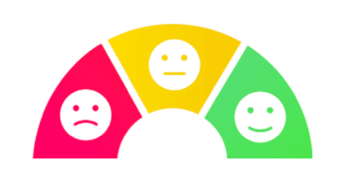 | You can give us feedback
What you need to do
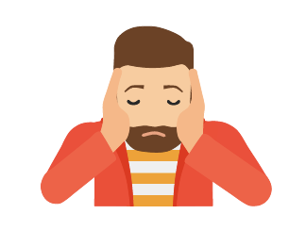 | You can make a complaint
 | You can tell us by Phone. 08 8643. 5600
You can tell us by writing a letter to:
PO Box 18. Port Augusta SA 5700
You can tell us by writing an email to:
qms@cobh.org.au
You can tell us on our website:
www.cobh.com.au/client-feedback
What you need to do
 | You can tell us in person
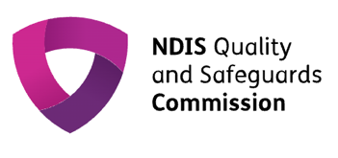 | If you do not want to talk to us, you can talk to NDIS Quality and Safeguarding Commission
 | By Phone: 1800 035 544 or TTY 133 677
On the NDIS Commission website:
www.ndiscommission.gov.au/about/complaints
What you need to do
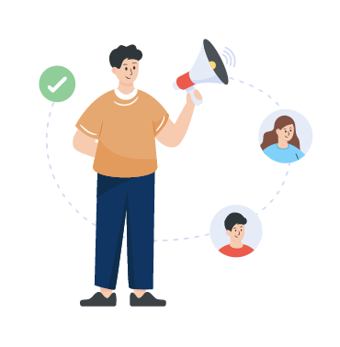 | You can use an advocate if you would like.  An advocate is someone who can talk for you and makes sure your needs are met. They could be a family member, friend, or from an organisation.
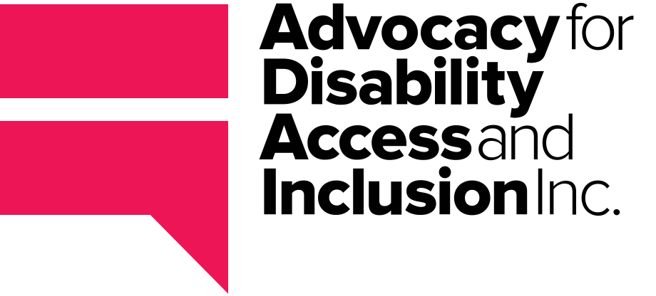 | You can access an advocate through Advocacy for Disability Access and Inclusion
 | On their website: www.advocacyfordisability.org.au
 | By Phone: 08 8340 4450
What you need to do
 | Disability Advocacy and Complaints Service of South Australia (DACSSA)
On their website:
www.dacssa.org.au
 | By Phone: 08 7122 6030
What we need to do
 | Give you supports that meet your needs
 | Give you supports that are part of your NDIS plan and up to the amount agreed to.
 | Tell you if your funds are running low.
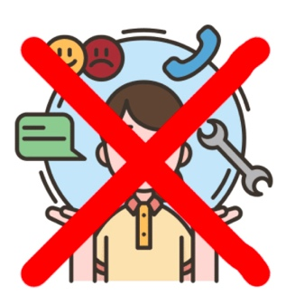 | Stop supports if you use more than you have funding for in your plan. We will talk to you about this before it happens.
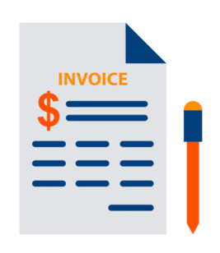 | If you self-manage, give you an invoice for you supports at least once a month.
What we need to do
Keep your information private.
Private means we will not share your information with others unless you agree for us to or we have to by law.
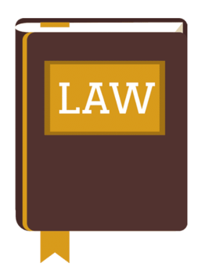 | We have to tell others your information even if you do not agree if you or someone else are not safe. This is the law.
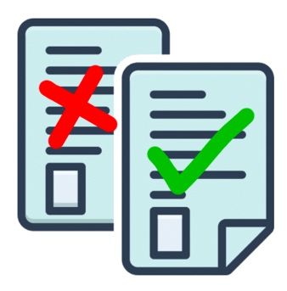 | When we share your information we will only share information that is important for the other people to know.
What both of us need to do together
 | Treat each other kindly and with respect
 | Work out a plan for your supports
 | Check how your supports are going
 | Talk to each other about your supports and funding
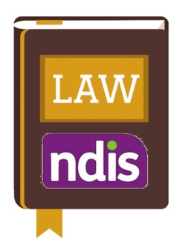 | Follow NDIS laws – the National Disability Insurance Scheme Act 2013
What both of us need to do together
 | Keep the paperwork for your supports
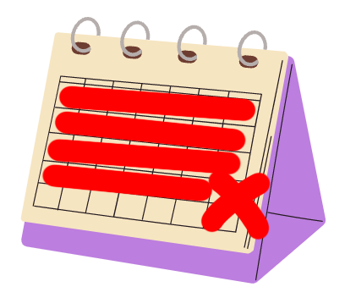 | Give 4 week’s notice if this agreement needs to end
 | Listen to feedback
 | Fix problems quickly
Paying for your supports
 | Funding is the money to pay your supports.
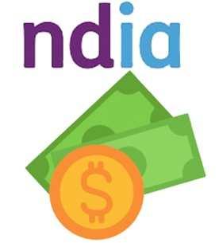 | If the National Disability Insurance Agency (NDIA) takes care of your funding, they will pay us for your supports.
 | If you have a plan management provider, they will pay us for your supports.
If you manage your own funding, you need to:

• Have enough funding to pay for our services
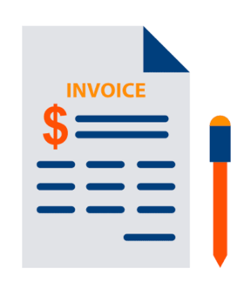 | • We will send you invoices that tell you how much you need to pay.
Paying for your supports
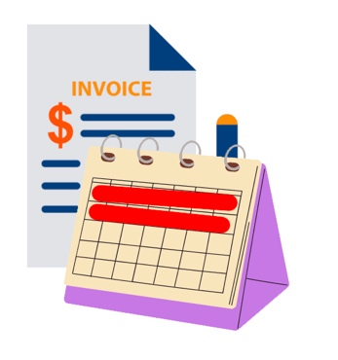 | • You will need to pay those invoices within  14 days.
 | • If you don’t, we might not be able to provide you with support.
Changing this agreement
 | This agreement might need to change
 | You might want to change it
 | We might want to change it
 | We will talk to you about any changes
Ending this agreement
 | You can end your service agreement at any time.
 | You will need to tell us 4 weeks before you want the agreement to end.
 | You can stop services as soon as you want to. We may need to do more work for you to make sure everything is finished up.
 | If we end the agreement, we will tell you 4 weeks before. We will try and help you find other supports to help you.
Cancelling Services
 | You must tell us if you need to cancel an appointment at least 2 days before
 | We may have to change you a fee if you don’t tell us.
Making the agreement
 | Please read and sign this page
 | I Understand and agree to everything in this agreement
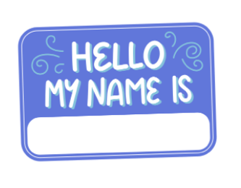 | Your name
 | Your signature
 | Todays Date
Making the agreement
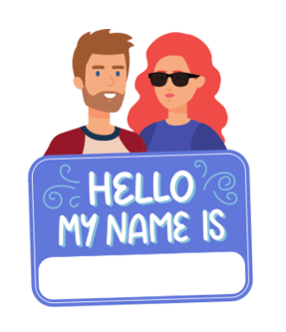 | Your parent, nominee or guardian’s name
 | Your parent, nominee or guardian’s Signature
 | Todays Date
Making the agreement
 | Your contact from Country & Outback Health reads and signs this page.
 | I accept this agreement for:
 | Staff Member’s name
 | Staff Member’s Signature
 | Today’s Date
 | This agreement needs to be checked on or before this date
Contact us
 | By Phone: 08 8643 5600
 | By email: admin@cobh.org.au
By Letter:
12 Chapel Street Port Augusta SA 5700
 | On our website: www.cobh.com.au

